**HOW TO INSTALL JDK**

**Step 1)** Go to google search write JDK for window or computer . Click on JDK Download for java.

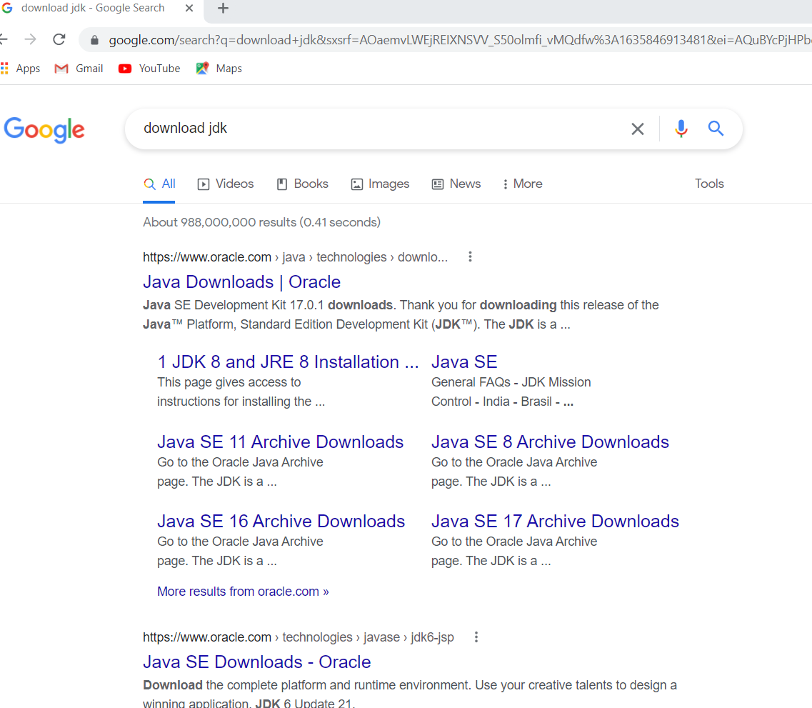

**Step 2)** Once the Java JDK download is complete, run the exe for install JDK. Click Next

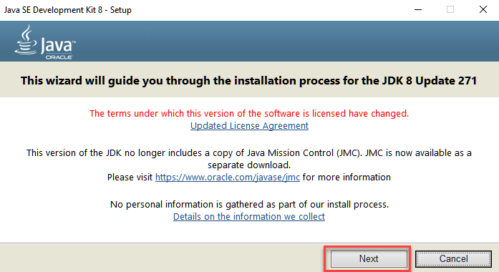

**Step 3)** Select the PATH to install Java in Windows… You can leave it Default. Click next.

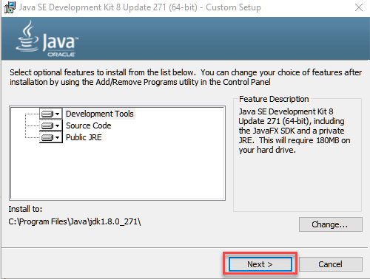

**NOTE:** Follow the instructions on screen in step by step to install JDK.

**Step 4)** Once you install Java in windows, click Close

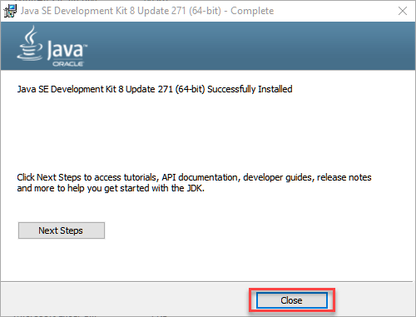

**How to Create Path and Classpath in java**

**Step 1)** Right Click on the My Computer and Select the properties

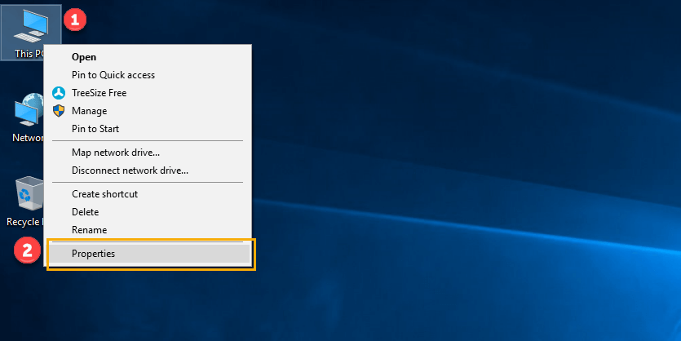

**Step 2)** Click on advanced system settings

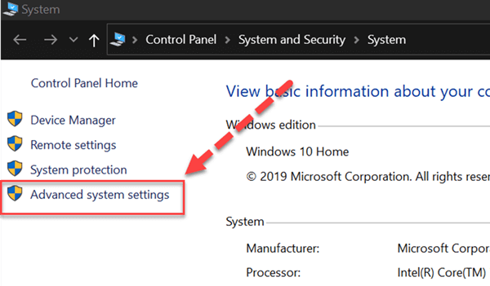

**Step 3)** Click on Environment Variables to set Java runtime environment

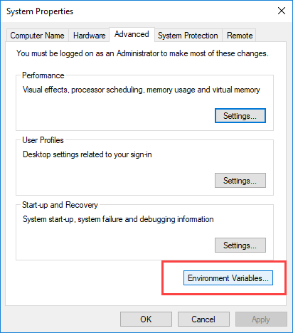

**Step 4)** Click on new Button of User variables

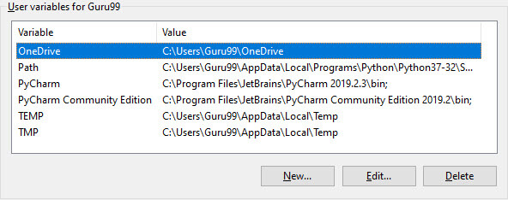

**Step 5)** Type PATH in the Variable name.

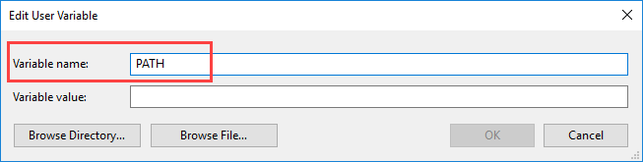

**Step 6)** Copy the path of bin folder which is installed in JDK folder.

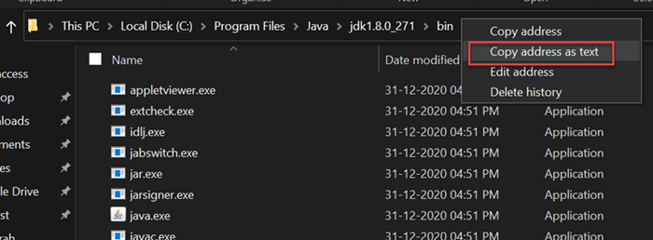

**Step 7)** Paste Path of bin folder in Variable value. Click on OK Button.

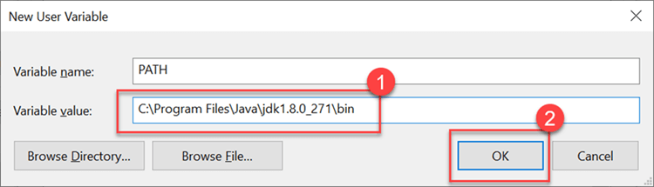

**Step 8)**You can follow a similar process to set CLASSPATH.

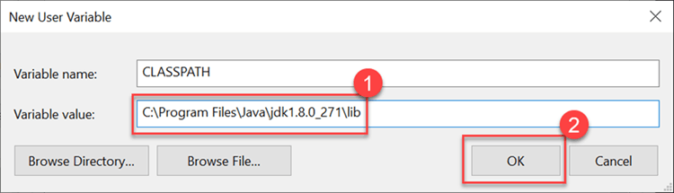

**Step 9)** Click on OK button

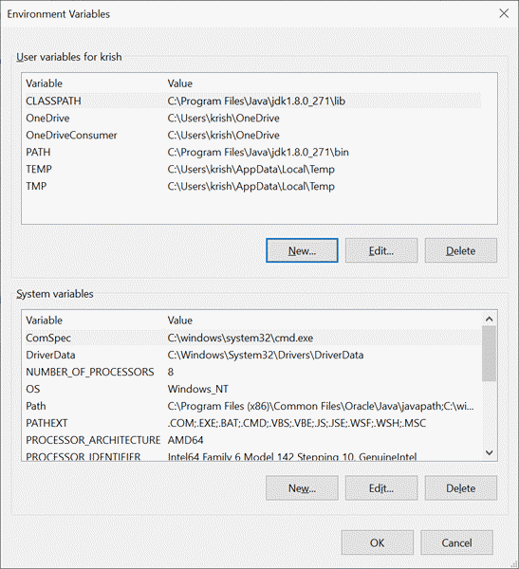

**Step 10)** Go to command prompt and type javac commands.If you see a screen like below, Java is installed.

